1. Maquina virtual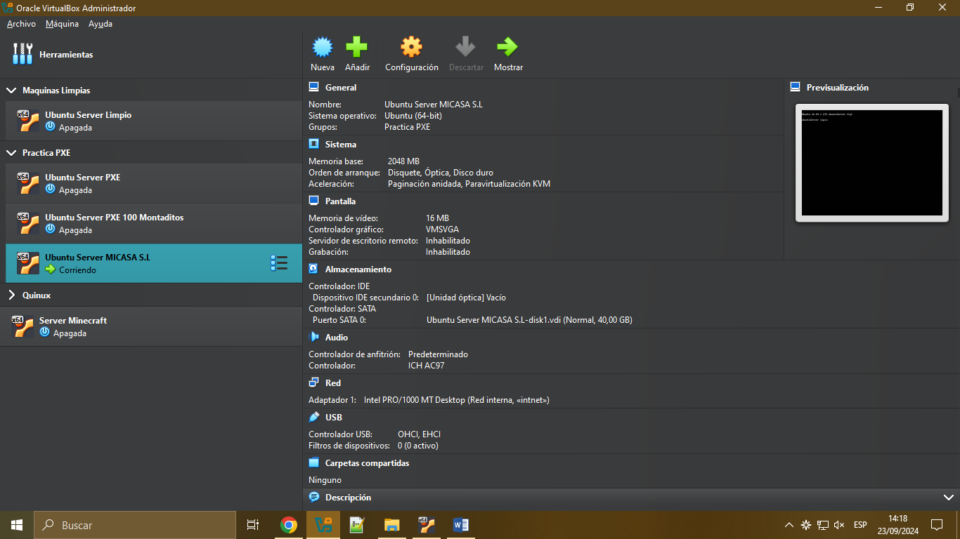
2. sudo apt-get install isc-dhcp-server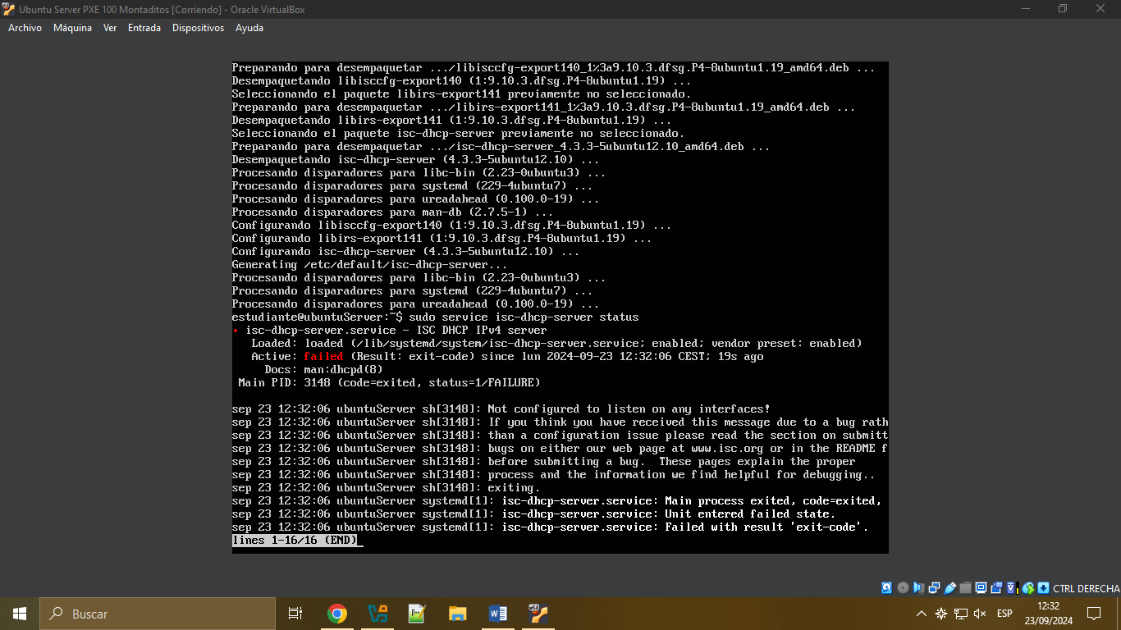
3. sudo apt-get install tftpd-hpa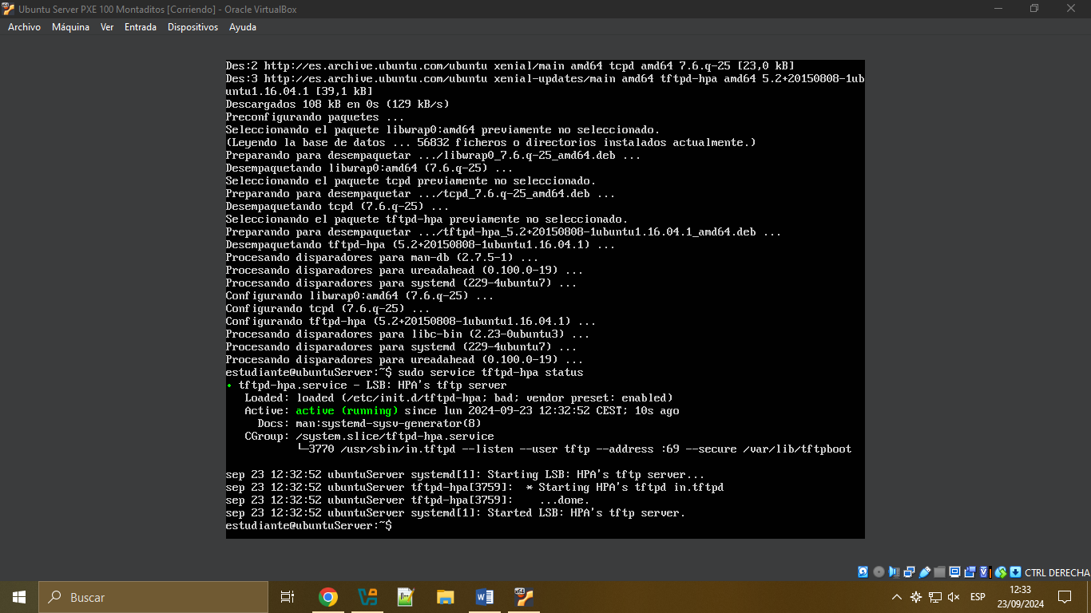
4. sudo nano /etc/network/interfaces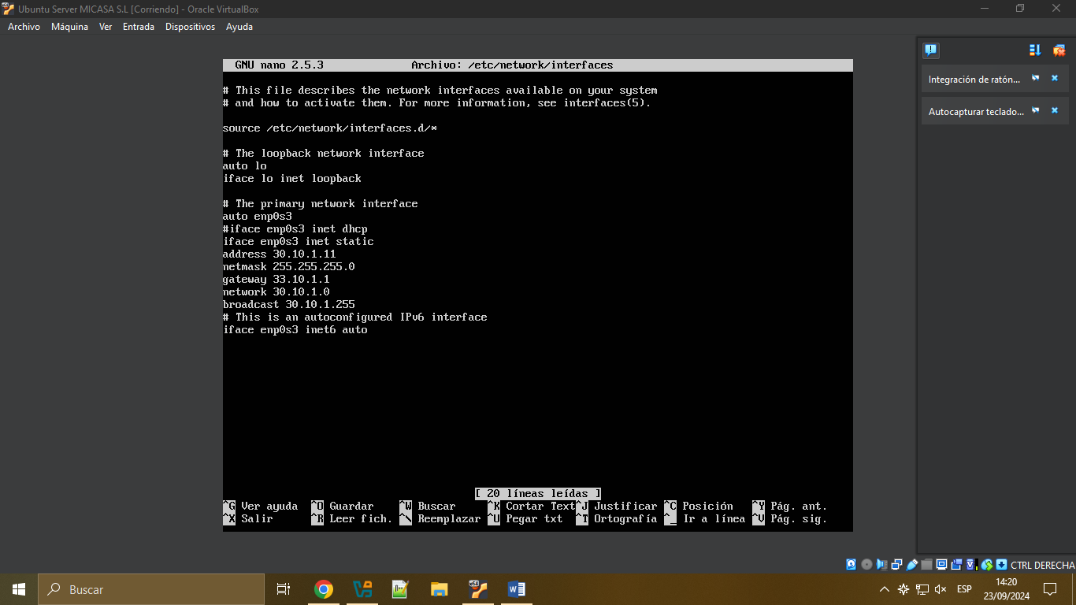
5. sudo nano /etc/default/isc-dhcp-server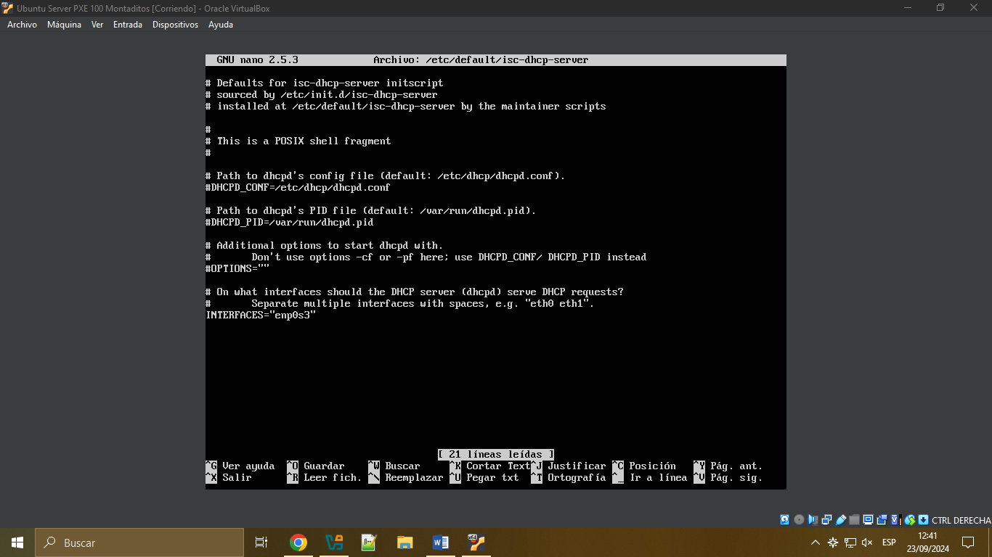
6. sudo nano /etc/dhcp/dhcpd.conf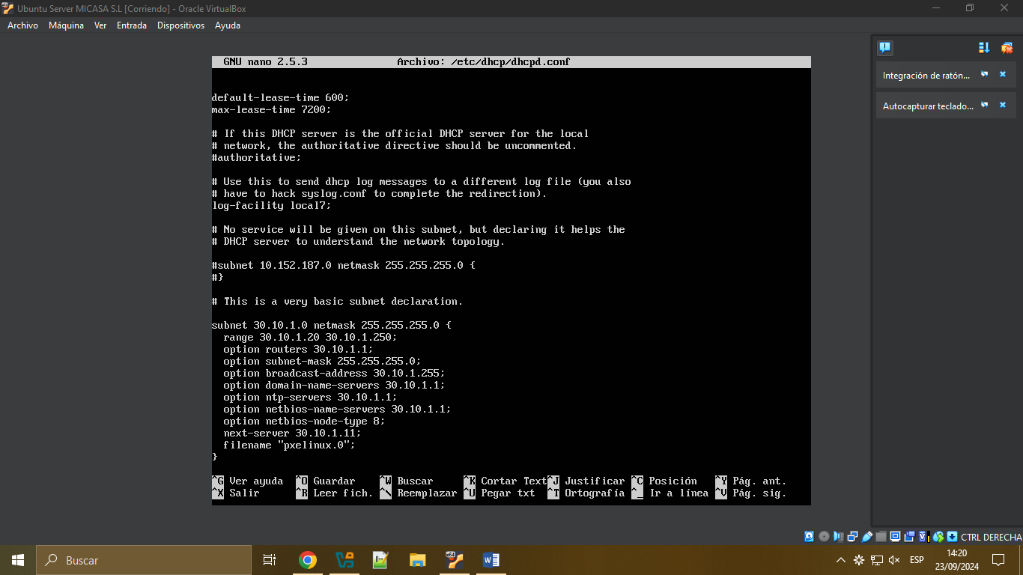
7. sudo nano /etc/default/tftpd-hpa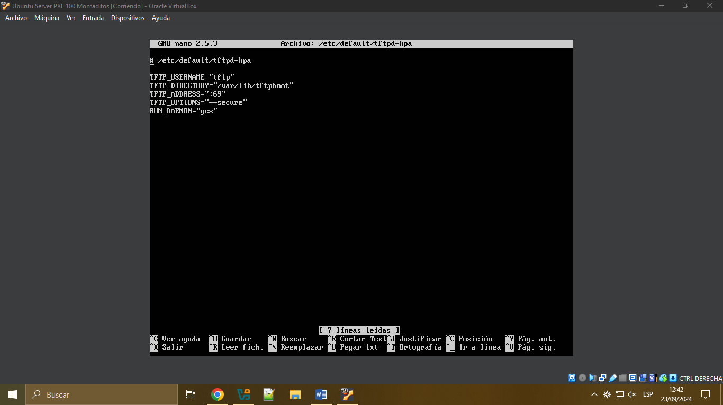
8. Conectamos ISO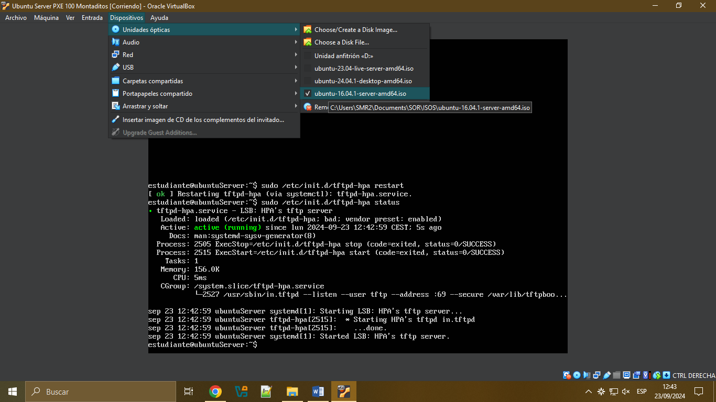
9. sudo mount /dev/cdrom /media/cdrom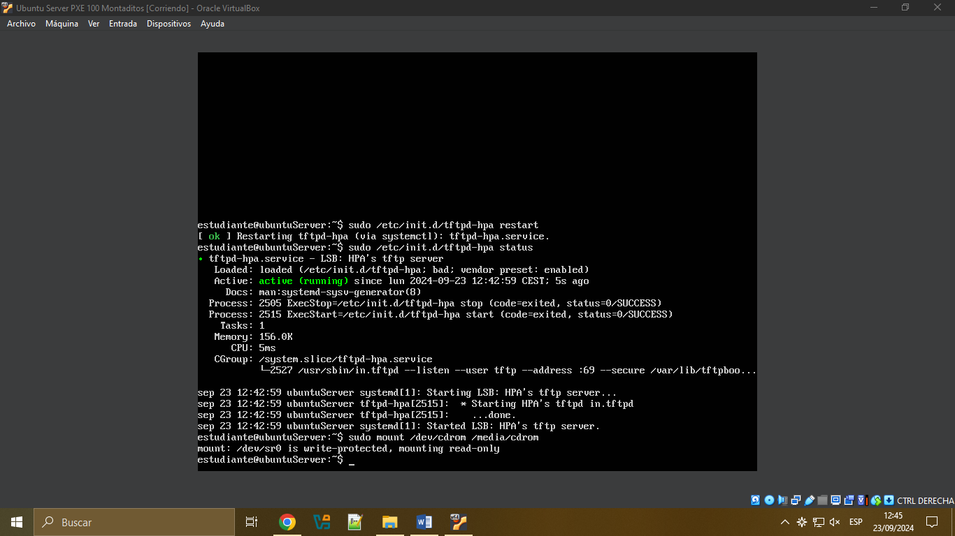
10. sudo cp -ar /media/cdrom/install/netboot/\* /var/lib/tftpboot/